Prioritize Your Ideas
Kill your darlings and make choices!
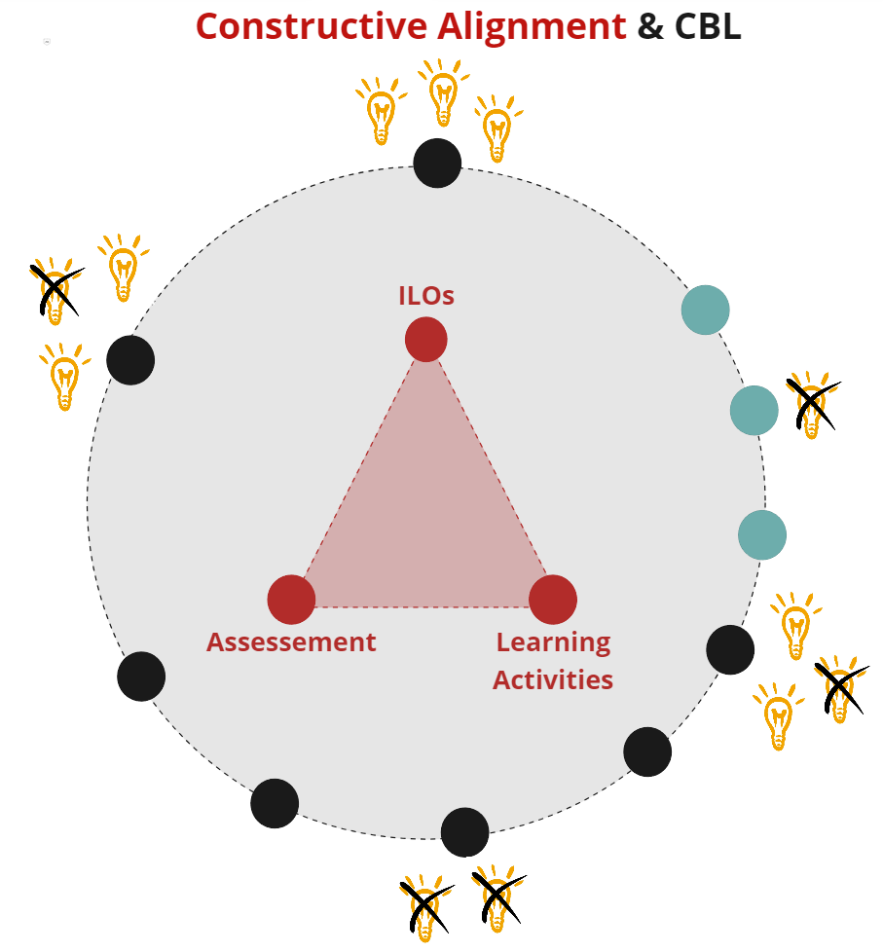
This tool assists you in prioritizing your ideas.

Materials
- Collection of all your ideas
- For live session: post-its, pens, printouts of worksheets.
- For online session: Miro template, charged laptop, internet.

TO DO
- Collect all your ideas in one overview and structure them.
- Prioritize your ideas by using the tools on the next page
- When you are done prioritizing, check that your ideas match the constructive alignment of your course. As a team, ponder this question: Do the intended learning outcomes, learning activities and assessment still match? What changes do we need to make?

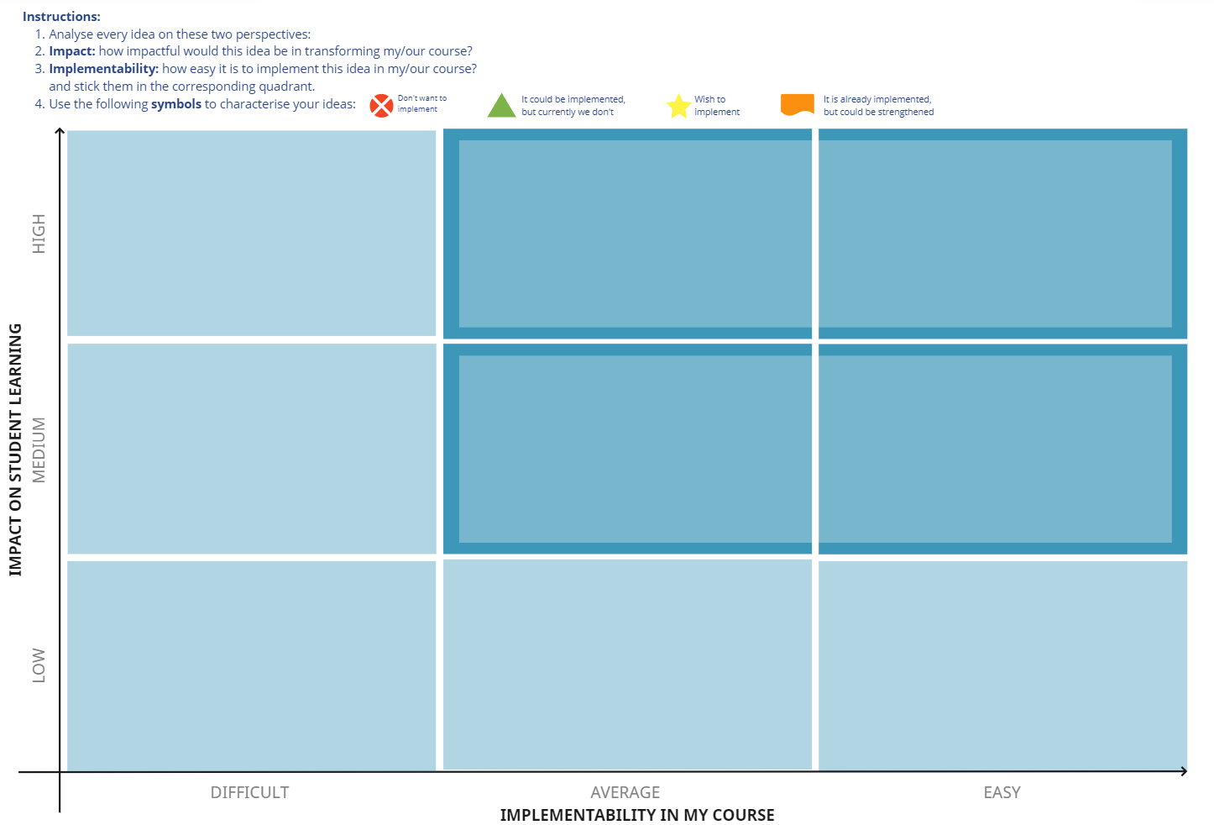
Pioritizing Tool

