CBL Precondition Analysis
This document helps you get a quick picture of what preliminary work you can build on, and what resources to call upon.

Gather insights from the previous course
If you are re-designing an existing course, use the overview below to gather information from this course which you can use as input for your re-design.

Note: if you are creating a CBL course or project from scratch, skip this step and continue with 2.

Question | Action + answer | What to do with my answer?
- Wat do you like of the previous course? | Type your answer here: | Answering these two questions helps you to find out how re-designing your CBL course can help you to improve your course.
- What would you like to change to your course? | Type your answer here:
- What materials from your previous course(s) or other courses or can you potentially reuse? | Create a list of re-usable content  ☐Course Schedule  ☐ Contacts (stakeholders, innovation space)  ☐ Format for Intended Learning Outcomes  ☐ Design frameworks  ☐ Learning journey  ☐ Assessment plan  ☐ Development plan  ☐ Rubrics  ☐ Study guide  ☐ Existing Lectures or study Materials | Not only will this save you time, using the same formats as your fellow educators will create consistency towards your students. This allows them to pay more attention to their learning process.

Set-up a list of preconditions
Use the overview below to map out all the prerequisites for your CBL course or project. Maybe your Quality Assurance Officer can help with gathering information from other courses or relevant department document.

Note: If you are creating a CBL Project, skip the first 3 questions. These questions are about the curriculum. As projects are self-contained and do not have to take any curriculum into account.

Question | Action + answer | What to do with my answer?
- Where is your course situated within the curriculum? | ☐ Bachelor, year …..  ☐ Master, year …… | The earlier your course takes place in the curriculum, the less complex you make it. In the beginning, students still need to get used to the approach, with students actually wanting to be challenged at the end. use the diagram below to determine which CBL elements you will apply.  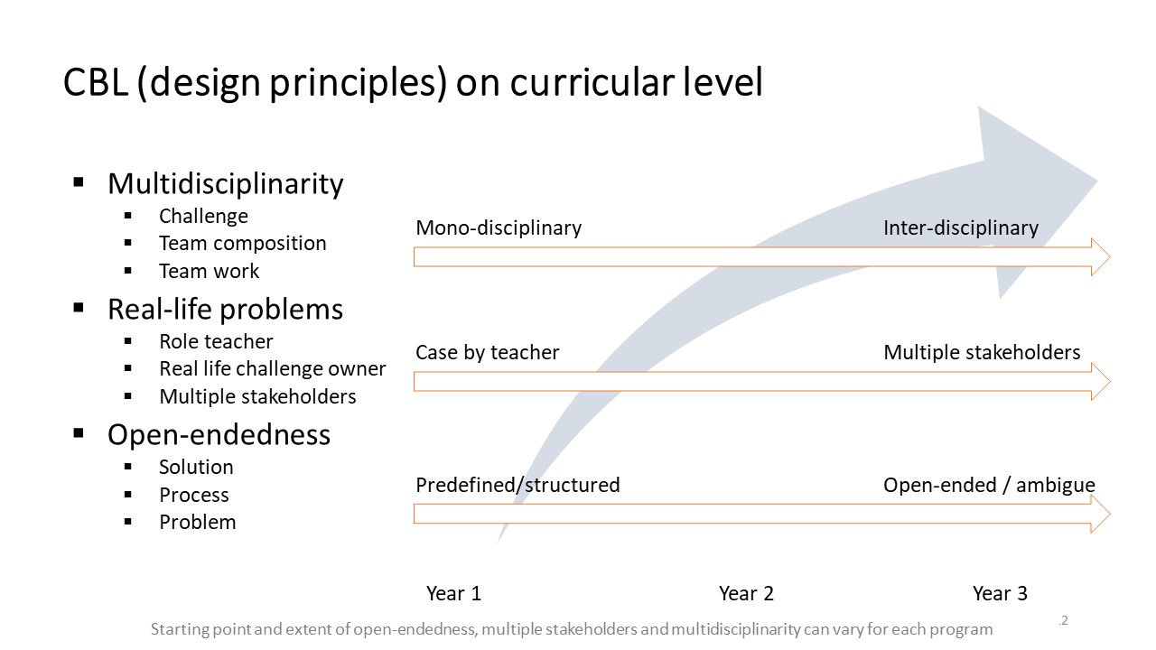
- If re-designing an existing course: What are the Intended Learning Outcomes (ILOs) of the previous course? | Type your answer here: | ILOs serve as a roadmap for both educators and students, helping to establish the expectations and goals for a course. A course integrates two types of Intended Learning Outcomes: subject-specific ILOs and Professional and Personal Development (P&PD) competencies.  You may want to modify the current ILOs to do CBL justice.  Do this in conjunction with the Program Director and already connect.  Send them a message now to get them involved at an early stage where you can use their advice.
- Which other courses are, or might be, related to this CBL course? Summarize their ILO’s and how they are assessed. | Course:  CBL: Yes/No  Challenge:  P&PD competencies ILO’s:  Subject-specific ILOs:  Assessment format:  Course:  CBL: Yes/No  Challenge:  P&PD competencies ILO’s:  Subject-specific ILOs:  Assessment format:  Course:  CBL: Yes/No  Challenge:  P&PD competencies ILO’s:  Subject-specific ILOs:  Assessment form: | You can write down the info as short as possible as its purpose is to create an overview. This will help you to choose the right ILOs, challenge and assessment of your course during the design phase.  If some courses already have covered some P&PD competencies, you might need to incorporate them. Some P&PD competencies may not have been covered yet are therefore welcome in your course.  This overview is also helpful for the  subject-specific ILOs of your course.  You now know on which prior knowledge you can base your subject on. If already know if you are developing a multidisciplinary course, make a summary of the prior knowledge of students from the different departments.  If you align with the assessment of other courses you can create a complementary learning experiences for students by using the same processes, rubrics,
- What is the expected contribution of your course to the expected learning outcomes of this curriculum? | Type your answer here: | The curriculum may already define the expected contribution for your course. If you know these in time, you can take them into account and use them during the design.
- What are the specific departmental guidelines, standards, or requirements related to CBL | Put all the links to relevant documents.  ☐ Department Vision:  ☐ Curriculum guidelines:  ☐ Department standards:  ☐ Available budget  ☐ Software or technology we can use | You department might already defined pre-conditions you have to take into account. Make sure you know them, this prevents double work.
- What deadlines do you need to take into account? What do you need to deliver? And when? | Deliverable:  Date:  Deliverable:  Date: | If you know your deliverables, you can begin planning backwards from there.  Do you need to have your new course approved by all parties? Please reach out to your teacher support, as the administrative process may take longer than expected.
- Estimate how many students do you expect to teach? | Estimated amount of students: | In CBL courses or projects, students work in groups and are mostly guided by tutors. If you can already estimate how many students, how big the groups are and how many facilitators are available, you can calculate whether you have enough facilitators or need to recruit them.  Rule of thumb:  - Student group sizes: 5-8 students.  - Amount of groups per tutor: 1-4 student groups.  - Amount of tutors per supervisor: 5 tutors  You can also use the 3. Group Size Planner of the Development and Implementation Plan to count the amount of students, tutors and supervisors.
- Has it already been established how many students are in one group? | ☐ Yes: …. Students per group  ☐ No
- How much assistance is available? | Teaching Assistants or other Tutors:  Supervisors of tutors:
- What are students experiences with CBL? What do they potentially find difficult? And what will they be good at? | Difficulties:  Strengths: | You might find information about student experiences in evaluations, but you can also organise short students interviews. The study associations of your department might have a secretary of Education in their board that could help you in gathering feedback from students.  This information is useful during the design phase. While designing, you can think of solutions to overcome the difficulties and make use of the strengths.
- What facilities can you use and what are any restrictions? | Write down the availability and restrictions  ☐ Meeting rooms:  ☐ Equipment:  ☐ Lab:  ☐ Software: | If the number of spaces is limited, it is important to know this before you start designing. The same goes for any equipment. If it has limited access, you need to take this into account during your design. Recourses you might be able to use:  TU/e innovation Space facilities and support  TU/e Living Labs settings and recourses.
- What other educators or colleagues have already have experience with CBL? | Name:  Name:  Name: | Schedule a meeting with them and ask them to help you or at least give you advice.  These people may be able to help you during the creation of your CBL course or project.
- Is the challenge already formulated? | ☐ Yes, one of the used challenges can be reused.  ☐ No, challenge can’t be repurposed  ☐ No, there is nothing yet. | If you can reuse a challenge, it saves work. Additionally, knowing which challenges have already been used and why they cannot be reused can be helpful later during the design phase.  If you find it challenging to create a challenge, remember that TU/e Innovation Space might be able to provide one for you.
- Are stakeholders already involved? If yes, what is their level of involvement? | ☐ No  ☐ Yes:  ☐ Inspirational  ☐ Mentoring  ☐ Co-creator | If you have stakeholders internal or external, involve them early in the process. You can create the challenge together. Also important to define their level of involvement and the corresponding responsibilities.  - Inspirational: The stakeholder gives an inspirational lecture of what challenges exist in the real-world to give an idea to the students how the challenge(s) given by the lecturer are related.  - Mentoring: The stakeholder is the challenge owner and meets with the student teams on a pre-defined basis (weekly, bi-weekly, etc), but does not participate in assessing the final output  - Co-creator: The stakeholder is the challenge owner and meets with the student team on a pre-defined basis (weekly, bi-weekly, etc) and participates in the co-creation of the solutions with the students (so it does not participate in assessing the final output but can contribute to evaluating an aspect of students work, such as teamwork aspect, etc)  If you find it challenging to find stakeholders, remember that TU/e Innovation Space might be able to provide one for you.

