Formulating a Challenge
A challenge is a specific real-world problem or scenario around which the course content revolves. If you have the foundations of your design in place, its time to formulate a challenge. If you already have a challenge you can re-use, check out the template for inspiration.

How do you generate ideas for a challenge?
- Innovation Space has more challenges than projects. Contact Innovation Space to see if there is a challenge that fits your course, and whether you can adopt it.
- From current trends and developments in your field, identify issues or problems that may appeal to students and whether they provoke deep research and creative solutions.
- Base your challenge on specific knowledge and competencies you want students to achieve.
- Ask students about their interests and what motivates them, extracting valuable challenges from the types of problems that appeal to them and are relevant to their future careers.
- Connect with a stakeholder from the industry, society, or science related to your field and inquire about problems that seem to persist without resolution. This is ideal material for a challenge.
- Craft a well-formulated prompt and explore whether an AI tool like ChatGPT can provide you with ideas. You might be surprised by the results.

The template below should enable you to define your challenge. Remember that you challenge doesn’t need to be perfect as students need to get accustomed to ill-defined questions which need to be designed to spark inquiry process rather than make them jump to finding solutions.

Challenge Template
Titel Challenge
Challenge owner and back ground information | - Internal, name:  - External organisation, name:
Challenge Description*
Product Description*
Product Characteristics*
Subject Matter*
Related Research theme or sustainable Development Goal*
*Explanation per element
- Challenge Description: Gives the context, the essential question of the challenge and describes wherein students are challenged.
- Product Description: describes the product that students will create. A product refers to any tangible output, either physical or digital, that students create as a response to the challenge they are given or choose to do (if a selection of challenges are offered).
For example e: a physical prototype, design, piece of software, a research paper, a feasibility study or policy recommendation, depending on the nature of the challenge.
- Product Characteristics: Outlines the characteristics of the expected product.
For example: "a prototype that must not cost more than 80 euros.", “the analysis must involve statistics”, “the product must be user-verified”.
- Subject Matter: Specifies the domain-specific information of the challenge.
For example: econometrics, photonics, linear algebra.
- Connection with TUe Research Themes and sustainable development goals.
For example: Sustainability and Circularity and goal 7: Affordable and clean energy
- Stakeholder Involvement (optional): if the previous characteristics allow for it, you can opt to involve an external stakeholder. The information provided reveals the interests/background of the stakeholder and what the stakeholder expects from students and the level of involvement (Inspirational, mentoring, co-creator). For example: "Factory SCK wants to halve their emissions."

How long can a challenge last?
A challenge lasts as long as it remains engaging for teachers and tutors. After all, you are the ones who see all the outcomes and must guide and assess them.
If you've heard all the solutions, you don't have to come up with a completely new challenge immediately. You can also just change the parameters. For example: "Your 3D print must fit inside a box", "Your control solution must utilize machine learning" or “Your analysis must start from classical mechanics”.
If you receive the same solution from all groups, you can exclude that option. For example, "No solutions based on weather-prediction App”.

Also keep in mind that the emphasis in CBL is on the process of learning, not just the final output. So even if the students' solutions converge to similar solutions (which could be the case for less open-ended discipline-based challenges), the pathway that students have travelled to get to those solutions will likely be diverse. Some evaluation should then include the reflection on “lessons learned” through this process.

Examples of challenges

Multiped robot
Bachelor College, 1st and 2nd year project, max 20 students
Short Challenge description
Monodisciplinairy
Mechanical Engineering

Challenge description
In this project, you will work in a group to design, fabricate and test a multiped robot that can walk on different terrains. You can use the provided components to power and control the robot. 3D printing and laser cutting processes will be available for the production of the parts,. After you build your robot, its performance will need to be measured on various types of terrains (different hardness, roughness and slopes, etc.) and the results will need to be analysed. You will also need to produce a simple model to describe the performance of the robot, which will need to be evaluated against the measurement data. As a group, you will produce a report in the end, which describes the design, prototyping, improvement, testing and the final analysis of your multiped robot.

Healthy Soundscapes in Shared Workspaces
Bachelor College, 1st year project, max 20 students
Monodisciplinair
Industrial design, Berry Eggen

Challenge description:
United Nations Sustainable Development Goals - #3 Good Health and Well-being: “Ensuring healthy lives and promoting well-being at all ages is essential to sustainable development.”

Within this UN goal, also healthy work- and study environments are important for the well-being of people. Within these environments, large parts of the population perform their daily tasks. These tasks range from concentrated activities like ‘writing’ to collaborative ‘brainstorm’ sessions. The environment has a big effect on how well these tasks can be performed. But what defines this environment? What are the defining elements and actors that need to share open-plan work- and study environment?

Sound, for sure, is one the important components of this environment. Actually, a very important one, because it is hard to instantly modify your sound environment and/or to adapt yourself to the environment in the moment. You cannot ‘close your ears’ and/or ‘listen away’ from the sound like you can ‘close your eyes’ and/or ‘look away’ to ignore visual information. But if you try to do, for example by covering your ears or by producing masking sounds, such actions often come with unwanted consequences; you miss out signals that need your attention to take immediate actions or you become isolated from your social environment. Getting rid of all disturbing sound might seem, at first, the best way to go. But, even if we would indeed be able to do that, we would immediately experience that some of the sounds we need to perform well have gone too. This calls for more intelligent sound solutions to be studied and developed.

The challenge offered in this project is to design a ‘passive’ object that supports and contributes to a healthy soundscape in an open-plan work- and study environment.
‘A passive sound amplifier’ could be one of the instances of such an object. A passive amplifier does not use electricity to amplify sound but uses physical principles to modify the sound. The physical construction and shape of the object, can, for example, change the loudness, timbre and direction of a sound source. In this project, we are going to use the omni-present smartphone as the source producing unwanted and wanted sounds in the work environment.

The living cell as a material
Bachelor College, 1st year project, max 20 students
Monodisciplinary
Research based
Applied Physics, L.M.C. Jansen

Context
Understanding and controlling the behavior of living cells, both in health and disease, has traditionally been the realm of biology and medicine. In recent years, however, there is a growing realization that the living cell can also be successfully described as a material from the perspective of physics, (mechanical) engineering, chemistry, and materials science. This new multidisciplinary perspective on cell behavior has already led to fundamentally new insights in biological processes such as wound healing, embryonic development, cancer metastasis, and asthma. For example, in studying the spreading of cancer in the body, scientists have historically focused mainly on genetic and biochemical factors; it is now becoming clear that the mechanical forces between cancer cells and the surrounding tissue are also a crucial, but previously overlooked, factor in this process. Ultimately, such physics-based insights can help to develop better therapeutic strategies to rationally control (pathological) cell behavior in the body.

Challenge description
This challenge aims to take a physics-based approach to understand the behavior of living cells. Possible research questions include:
- By which (differential) equations can the motion of a single cell be successfully described (in vitro and/or in vivo)? Which forces are at play, and how to they affect the cell motion?
- How do cells actually move? Which forces do they exert on their surroundings, and how much work is done by a cell to move?
- How can we tell whether an object is living or non-living? How would the equation of motions differ, how would the energy balances differ, etc.?
- Which kinds of synthetic materials would most closely resemble the features of a living cell? (e.g. in terms of the viscosity of the cytoplasm, elasticity of the membrane, etc.) What would be needed to build a synthetic cell in terms of its material properties?

Example: Pulsar Navigation
Extensive Challenge description
Bachelor College
Monodisciplinairy
Combination of research with prescribed phasing and prototyping
Electrical Engineering, M. Bentum

Background information
Can you imagine a world without GPS navigation? If you want to get somewhere in your car, find a restaurant close by or even find directions if you walk around a new city center. In all these cases your cell phone or car navigation system is using the signals from GPS (Global Positioning System) satellites (or soon: Galileo satellites). These signals are received by your device and with use of intelligent software your exact position on the Earth can be determined.

But …. The GPS system is not always working and even more worrying, it is possible to jam and spoof the signals. A GPS spoofing attack attempts to deceive a GPS receiver by broadcasting fake GPS signals, structured to resemble a set of normal GPS signals, or by rebroadcasting genuine signals captured elsewhere or at a different time. These spoofed signals may be modified in such a way as to cause the receiver to estimate its position to be somewhere other than where it actually is, or to be located where it is but at a different time, as determined by the attacker. This has been shown for GSM in combination with games like Pokémon-go. Chasing the newest Pokémon in for instance New York, while sitting in your own home using a GSM spoofing device. But, you can also imagine some more harmful situations.

A more resilient solution is to use natural signals instead of man-made signals. A possibility is the use of Pulsar signals. Pulsars (Pulsating stars) are fast rotating neutron stars that emit electromagnetic radiation, which is received anywhere in our solar system as a series of very stable fast periodic pulses. Radio pulsars can act as timing sources for a navigation system.

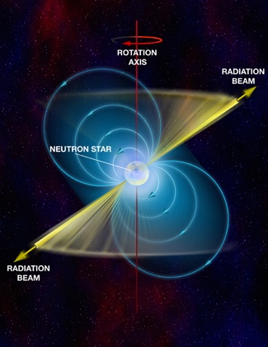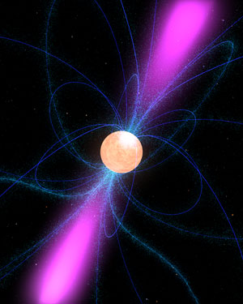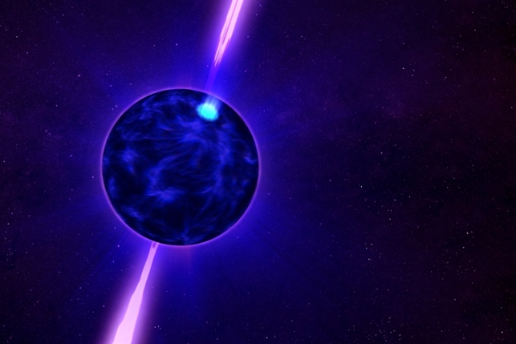

Recent advances in technology have given motivation to investigate whether these could enable faster and more accurate detection of pulsar signals. The main benefits of a navigation system based on pulsars include resistance to jamming and spoofing, resistance to extreme space weather, resistance to failures, and political independence.

In this challenge we will work on pulsars and pulsar signals. You will learn about radio astronomy, pulsar timing, data analysis, technology to determine position, societal impact.

Phase 1: research
First thing to do, is to become acquainted with the theory of pulsars, data analysis of pulsar signals and positioning. Therefore, the following steps should be taken in your group:

- Background research on pulsars. What makes the signals, what is the stability of it, are there pulsars everywhere in the Sky, what is the strength of the signals, what is the mathematical background on pulsars?
- Background research on the detection of pulsars. We will provide real (!!) data measured with the Westerbork Synthesis Radio Telescopes, including a pulsar signal (B0329+54). We will provide MATLAB code to detect the pulsar in the data. You can play with it, while learning about pulsars, MATLAB and the physics behind this.
- Background research on positioning using weak GPS signals. What is necessary to calculate your position, what are the limitations, what are the spoofing possibilities, …?
- Background research on the use of navigation in current, but also future applications. What are promising, but safety critical applications, what might be the benefit of pulsar navigation?

The research includes the search for relevant material (papers, books, explanatory lectures, videos on the internet, etc,). Of course, we will provide you with information as well. The output of all these steps is a small report, which can be included in the final report and presentation. Each of your group can work out one of these steps. It is the basis for the next step of this challenge.

Phase 2: Design
Suppose we are asked to design a complete spoofing-free navigation system using pulsars. What will be a good application for this (technology push)? Why is this depending on spoofing-free technology? What would be the societal impact? How can we implement this?

The output of this challenge is a presentation to advertise this application and technology. A nice prototype (not necessarily a working prototype… that would be almost impossible to realize ), that shows the working principle. The idea is that the presentation of this would lead to the next phase of such a project. ESA (European Space Agency) is using the term ‘Phase-A study’ for this. That is exactly the plan here. The next phase, (Phase-B), will be to work out this idea in more detail.

The Underground Challenge
External stakeholder: Dutch police
Bachelor College
Multidisciplinairy
Innovation Space, Marcel Derks

About the Challenge owner
During our work we are frequently confronted with the consequences of drug
production in the Netherlands. serious pollution of the environment, dangerous
living situations for and danger to public health. Our mission is to prevent this
situation by early discovering and dismantling production sites.

We can provide knowledge, expertise, and hardware of a production site for the benefit of the challenge. The solution of this challenge helps our organization with the detection of production sites. It also would help society in general given the harmful effects as described earlier.

Challenge description
In the past, we tended to look for hemp growers by flying helicopters over densely populated areas on days when it had snowed. Rooftops that were free of snow were an indication that something criminal was done there. With the growing number of drug labs, we had to improve our identification techniques. This has helped us a lot, but now it seems that criminals are taking their production sites underground, where our current localization techniques are not sufficient. We encountered underground labs before, and found an array of hardware that produces vibrations, specific sounds, or operates at certain wavelengths. We are currently unable to locate these labs from above the ground, and we are not allowed to simply enter any building without a permit. This is where we need you. We want you to come up with innovative ideas to detect underground drug labs from above. The public prosecutor is heavily interested in this process, and your contribution might be groundbreaking in our pursue to catch criminals. The challenge contains elements of sensing and detection of various types of signals, whichever signals you deem relevant. We can provide you with a hardware package from an actual hemp farmto build a testing environment for the detection of these devices.

Roles of different disciplines (only for ISBEP)
Architecture, Urbanism and Building Sciences: As we are potentially looking for signals that we need to be able to detect through layers of soil, concrete, wood, metal, orwhatever creative ideas the criminals came up with, knowledge of how certain sounds or other types of waves move through these materials can help understand which detection tool to use.
Electrical Engineering: Understanding the power and heat flows through the hardware components (and their close environment) can inform us about which sensing methods to apply.
Biomedical Engineering: Knowledge in molecular biosensing might be valuable in this challenge. Furthermore, BME students could provide value due to their contributions in image acquisition and processing.

Sustainable Airline
External stakeholder: Sustainable Aviation Youth Foundation (SAYF)
Master
Multidisciplinairy
Innovation Space, Thomas Driessen

About the challenge owner
SAYF’s vision is to facilitate youth engagement within the aviation industry as it is going through a major transformation. The path towards a more sustainable sector is a complex one that should involve youth as much as other types of actors. The Foundation will therefore allow youth to be part of this transformation by raising their voices and giving them a spot at the decisionmaking table. One objective is also to help members of SAYF on their professional journey by sharing opportunities and knowledge on specific fields of expertise. The overall goal is therefore to make sure youth voices matter and are being considered by all industry stakeholders.

Challenge description
The students are challenged to ideate and develop a disruptive start-up in the aviation industry. This could potentially be prompted by the ideation of a sustainable (zero-emission) airline (whatever it takes) which relies on the currently available sustainable technologies but may also be changed throughout the course to any subject that interfaces with the development of a sustainable airline. If the students ideate an incredible idea outside of the scope of a sustainable airline, for example, a new disruptive sustainable technology, or a disruptive environmental tool that can be connected to a viable business case, we will gladly support the students to pursue such interests.

Goals
- For students to evaluate the current sustainable technologies related to aviation.
- To reach out to all relevant stakeholder for a sustainable airline.
- Design and user test a business plan.
- Develop tools for stakeholders to convince the value of sustainable airlines to their business. (Calculations regarding emissions, and costs benefits for an airport to close a deal with a sustainable airline instead of a regular one)
- Promote their sustainable via our existing network, and the one they have developed throughout this course.

Possible components fitting in the work of the project group
- There are many aspects relating to the evaluation of the plethora of technologies that are available for the aviation industry at this moment. Furthermore, the development of emission tools for stakeholders (e.g., airports and aircraft OEMs) to convince that the technology, chosen by the students, is environmentally and financially beneficial. These tools can be implemented in websites for example (which could even be an independent start-up idea, that the students may pursue) in collaboration with our closest partner UN ICAO, which have a department dedicated to such tools (UN ICAO E-tools)
- Inter-modal transport business plans and technologies are supported equally. For example, start-up ideas to combine the aviation infrastructure with rail transport with the goal of reducing emissions on frequently travelled routes. Or designing multi-model transport hubs, and technologies that are required for such innovations in the future may be considered.
- The development of a business plan and a timeline towards a minimum viable product to present for stakeholders in the future. Reaching out to stakeholders in the industry is paramount for the students to design and perfect their business plan. Our network of stakeholders in the industry can function as a catalyst for the students to reach out to potential stakeholders that are usually hard to reach for students.
- Students have the freedom to ideate their own start-up and pursue this project after the course has finished, where we will support them continuously with our network and platform for young passionate entrepreneurs to collaborate in the aviation sector on a global scale.

