Course Ideation
Generate a realm of ideas!
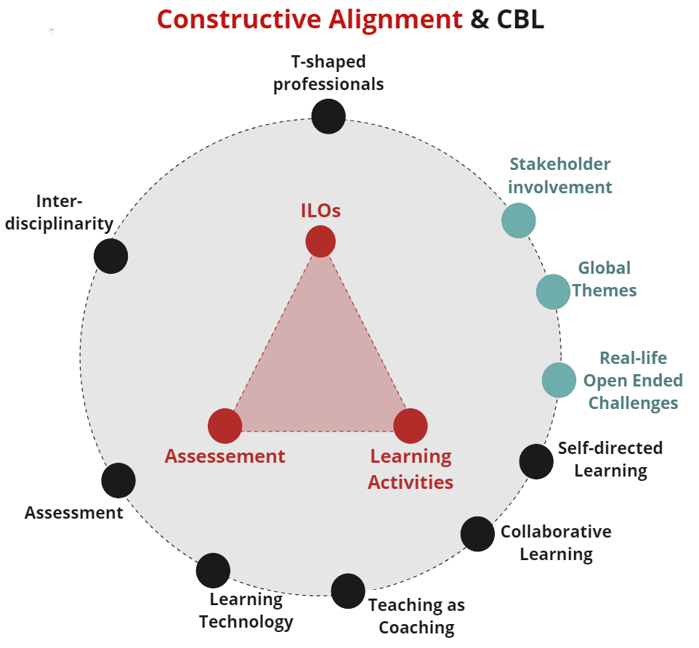
This tool assists you in enriching your basic design with more brilliant ideas. You can brainstorm yourself using the guiding questions or use the methods Innovation Space created for every CBL dimension. As you can see in the picture all ten dimensions can be related to the components of constructive alignment.

Have these design exercises guided by your Teacher Support. They are trained to do this.

Materials
- For live session: post-its, pens, printouts of worksheets.
- For online session: Miro, charged laptop, internet.

TO DO
- Use your Design Brief and your Course Foundation to choose which dimension to start with and which to do later. We recommend starting with a maximum of 3.
- Every method takes 20-45 minutes.
- Read the Methods instructions and execute them.

Wrapping up
- Gather all the output of ideas you’ve created and structure them, combine matching ideas.
- Optional: Do a last idea round based on all the output following design question: How might we combine idea X with idea Y?
- When you are finished with ideation, reflect on the ILOs, Learning Activities, Assessment and Challenge: Do we have enough ideas to cover all the four components? Gather new ideas if needed.

Intended Learning Outcomes (ILOs) | Learning Activities | Assessment | Challenge
Methods for designing by dimension  T-Shaped Professionals  Interdisciplinarity | Methods for designing by dimension  Self-directed Learning  Collaborative Learning  Learning Technology  Teaching as Coaching | Methods for designing by dimension  Assessment as Learning | Methods for designing by dimension Stakeholder Involvement  Global Themes  Real-life Open Ended Challenges

Overview of all Methods for designing by dimension
- T shaped professionals
- Self-directed Learning
- Collaborative Learning
- Learning Technology
- Interdisciplinarity
- Teaching as Coaching
- Stakeholder Involvement
- Global Themes
- Real-life Open Ended Challenges
- Assessment as Learning
