Course Foundation
Get your course off the ground!
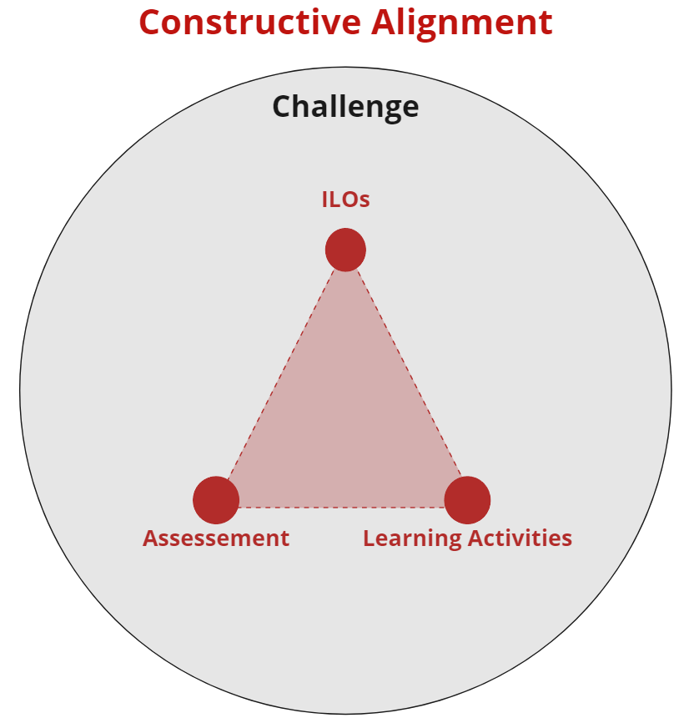
This tool helps you to get started with your design. Using the four components of constructive alignment.

TO DO
- Read the guiding questions and decide with which component you would like to start.
- Fill out your answers in the row below. Feel free to use AI for inspiration and to add more ideas than the questions guide you to. You can do this in several ways. Two examples:
  - Project this document on a beamer and fill out your answers collectively in this document.
  - Everyone writes down their own ideas first on post-its or their own note. Then you collect the ideas and merge them.
- When finished: reflect on the ILOs, Learning Activities and Assessment: What changes do we need to make for all components to match?

Intended Learning Outcomes (ILOs) | Learning Activities | Assessment | Challenge
Guiding questions | Guiding questions | Guiding questions | Guiding questions
- What is the topic of your course/project  - What prior knowledge of the students can I expect?  - In short: what content could be covered in your course?  - What do you hope students will learn during your course/project? | - Do you want students to work according to a certain process or framework? If yes, which one? (double diamond, scientific inquiry, double diamond …)  - Which assignments could you give students to learn what’s needed? | - How would you like to follow the progress?  - How would you like to measure the learnings? | - Wherein do you want to challenge student? What is the essential question?  - Product: What output could students deliver after the course/project (software, prototype, research paper, …)  - Product Characteristics: outline the characteristics of the expected product.
Our basic ideas | Our basic ideas | Our basic ideas | Our basic ideas
[Type here] | [Type here] | [Type here] | [Type here]

