CBL Aspiration Wheel
This tool assists you to determine per CBL dimension how motivated you are to implement it in your course/project.
Follow the three steps below to find out the aspirations of your course/project.

Delve into the CBL dimensions
Go to the page 10 dimensions of CBL and read the description of each CBL dimension.

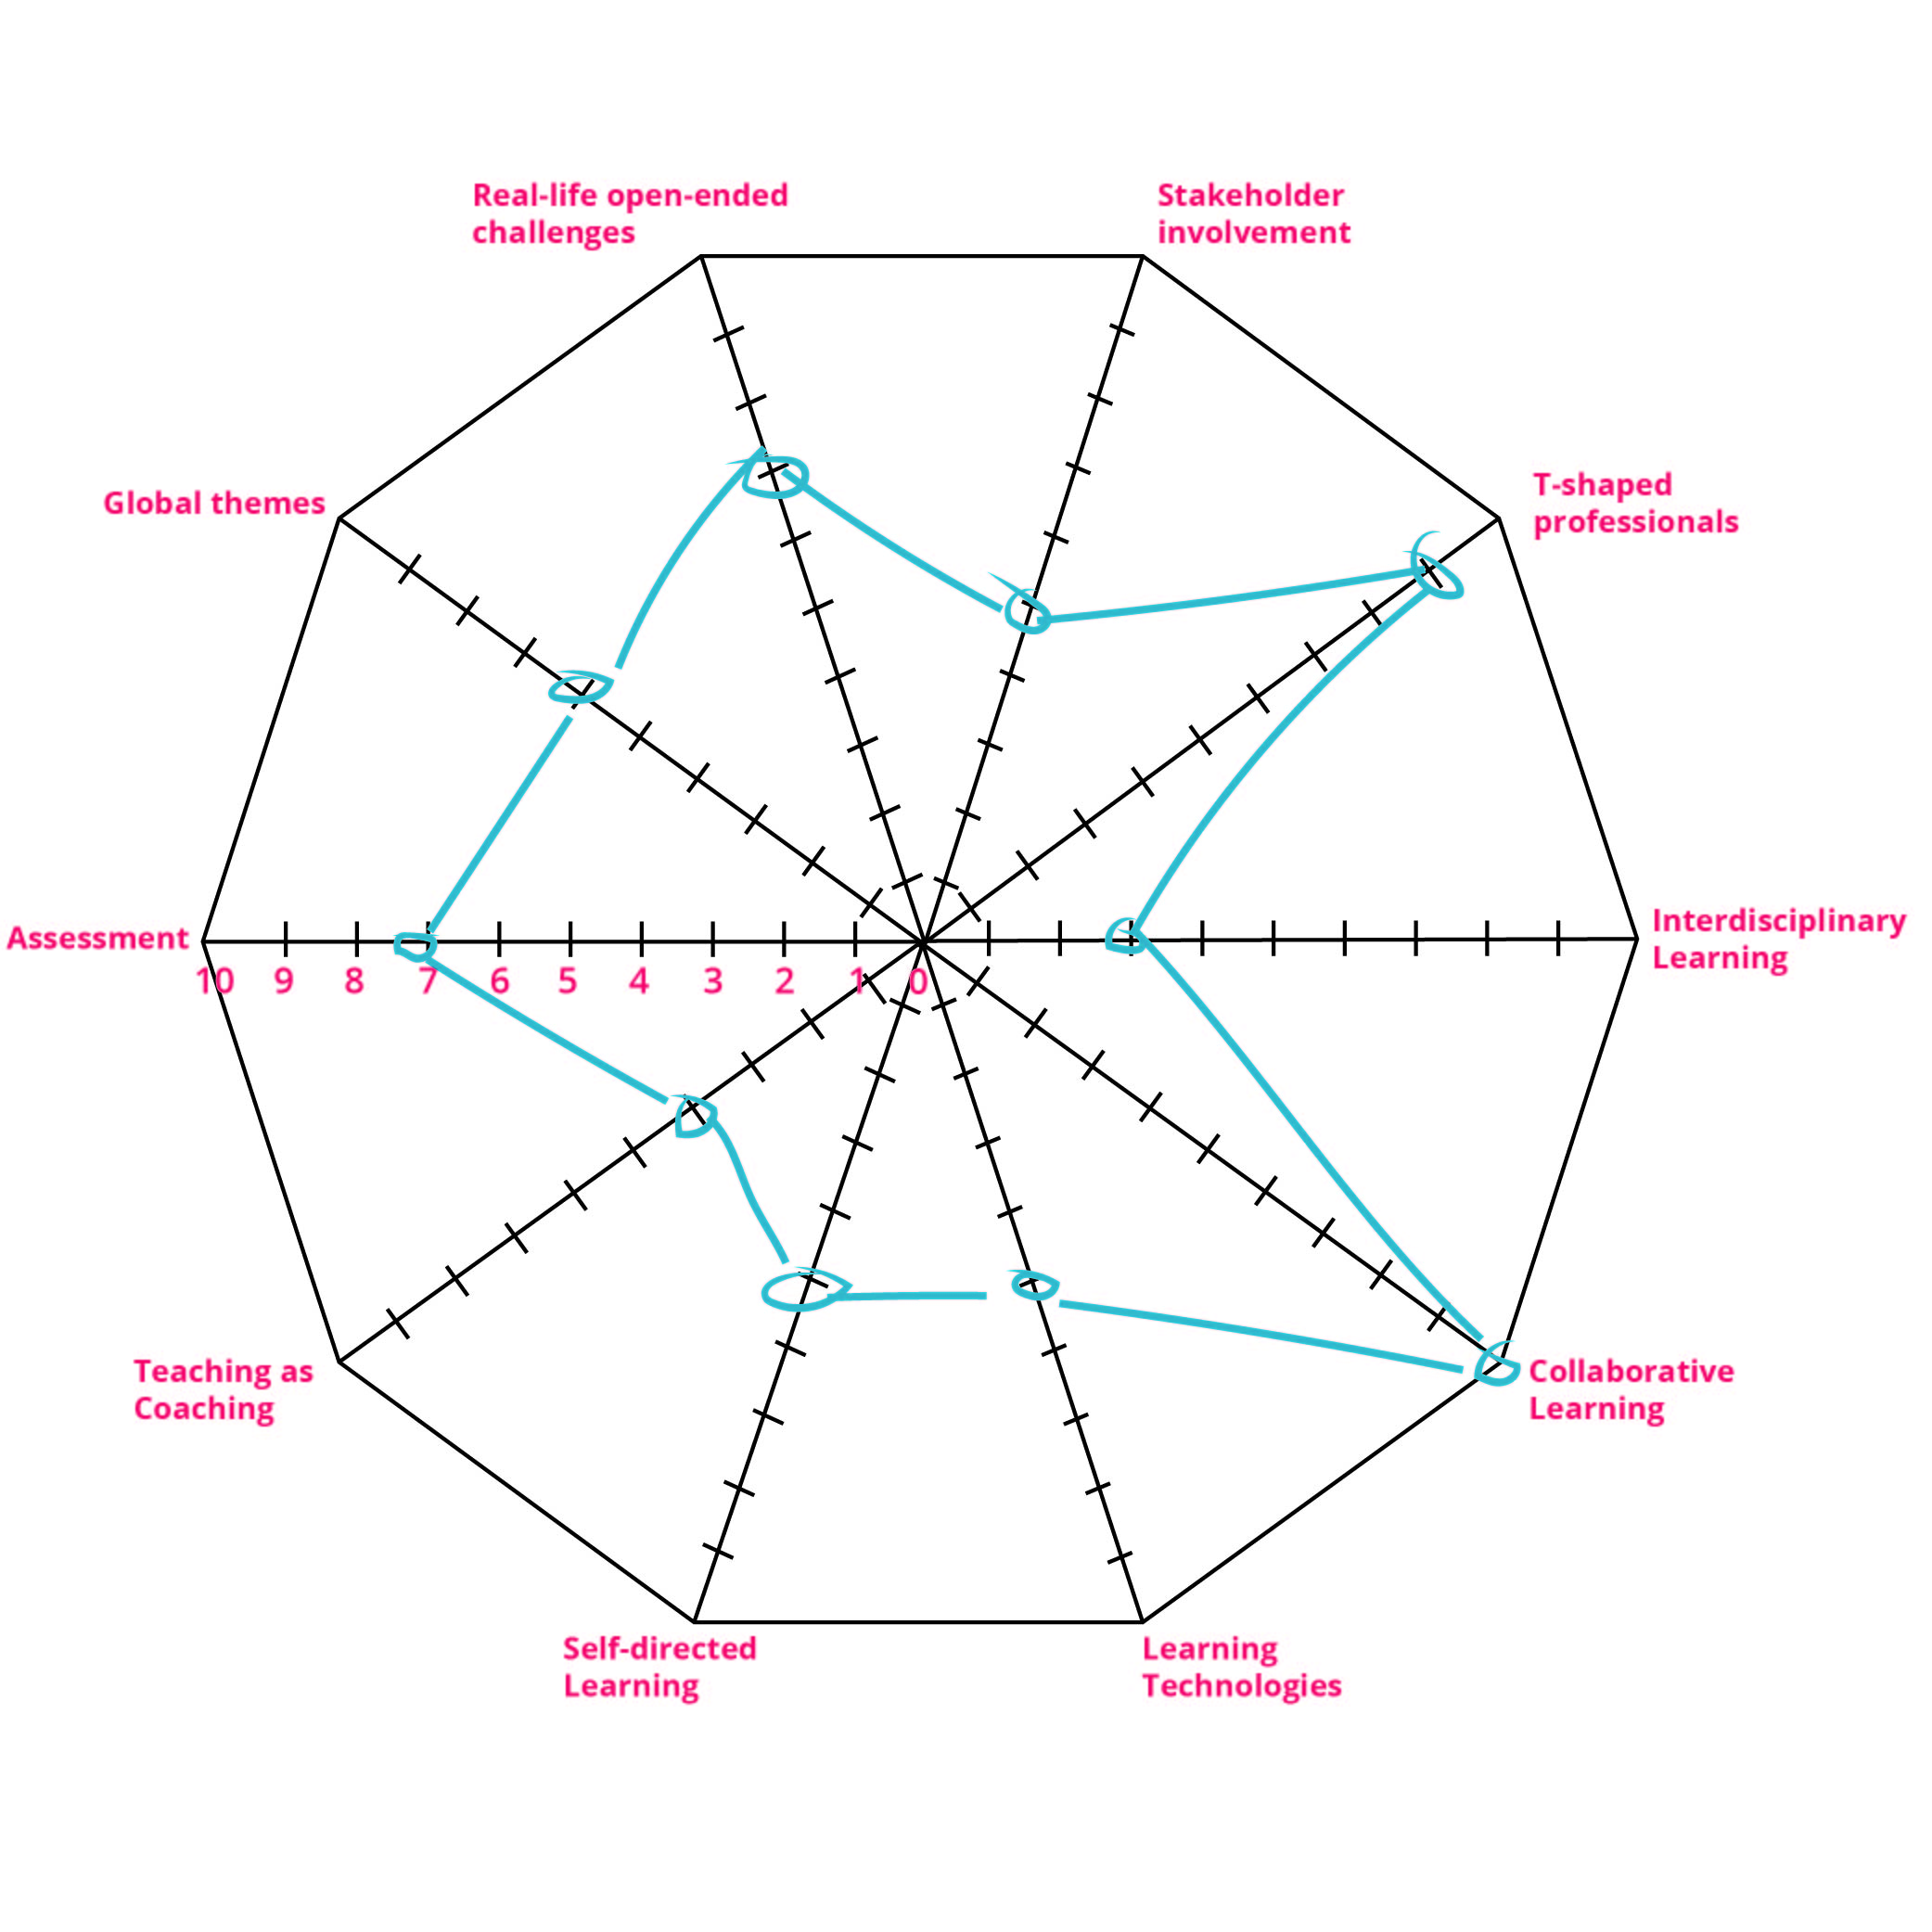
Score your performance on each dimension using the wheel below
Example completed wheel
- Look at the wheel from the next page and print it out.
- Consider your own course/project and give yourself a score for each dimension of the CBL, by marking it on the wheel below.
1 ( = performing poorly, or not present at all)
10 ( = performing in an excellent way and fully implemented)
- Connect the marks on the wheel: the resulting “spiderweb” is the visualization of how you currently perceive each element of CBL in your course/element. What insight does this give you?

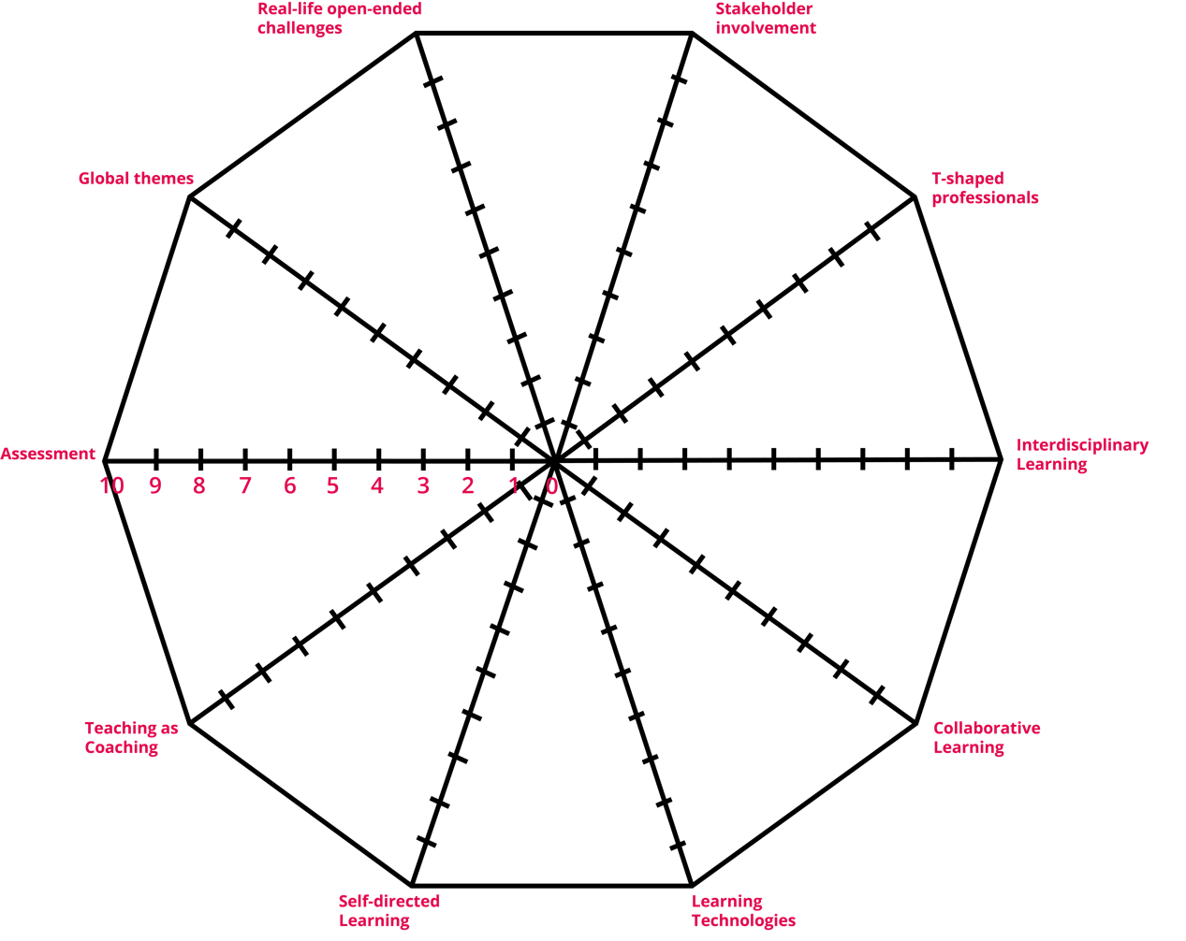

Report the score on the wheel in the table below
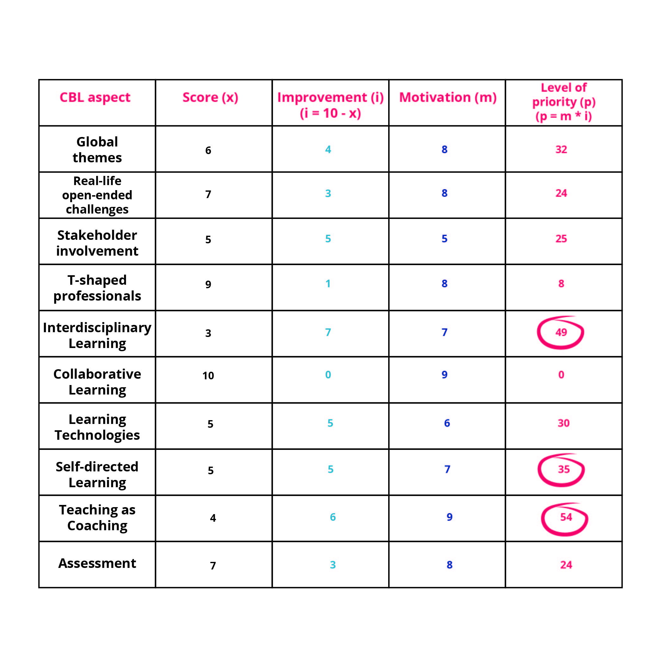
- In the table below, write your score on the wheel in the first column: Score.
Example completed table
- Then go to the Improvement column and indicate how much room for improvement there is per aspect in the second column. This number is calculated with the formula 10 minus the score you gave in the first column (Score).
- Now go to the Motivation column: indicate how much motivation you have to improve each aspect. Give a score between 1 (no motivation) and 10 (great motivation).
- Finally, go to the Level of Priority column. Determine the level of priority. This will show which aspects of CBL are best to start with. Work out the level of priority by multiplying the numbers in the ‘Improvement’ column by the number in the Motivation column.

CBL Aspiration Score
CBL aspect | Score (x) | Improvement (i)  (i= 10 – x) | Motivation (m) | Level of priority (p)  (p= i*m)
Global themes
Real-life open-ended challenges
Stakeholder involvement
T-shaped professionals
Interdisciplinary learning
Collaborative learning
Learning technologies
Self-directed learning
Teaching as coaching
Assessment

